- POT AND SERVO
#include <Servo.h>
Servo myservo;
void setup(){
myservo.attach(5);
Serial.begin(9600);
pinMode(A0,INPUT);}
void loop(){
int data=analogRead(A0);
int mydata=map(data,0,1023,0,180);
myservo.write(mydata);}
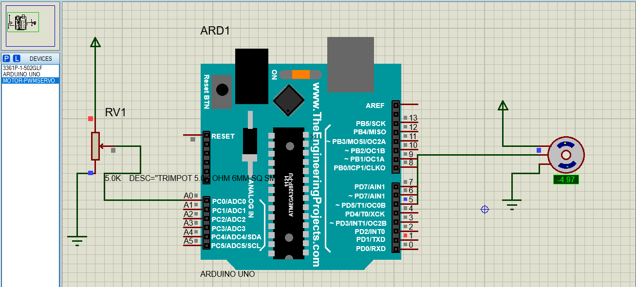
2. STEPPER
#include <Stepper.h>
const int apr =40;
Stepper steper(apr, 8, 9, 10, 11);
void setup(){
steper.setSpeed(10);
Serial.begin(9600);}
void loop(){
steper.step(apr);
delay(1000);
steper.step(-apr);
delay(1000);}
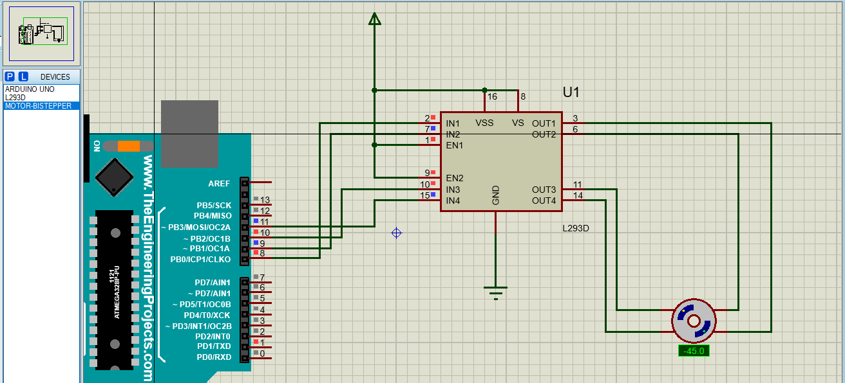
3A ANALOG (LED based on the LDR (Light Dependent Resistor -Analog sensor) sensor)
int x;
void setup(){
pinMode(10,OUTPUT);
pinMode(11, OUTPUT);
Serial.begin(9600);}
void loop(){
x= analogRead(A0);
Serial.println(x);
if (x<500)
{
digitalWrite(10,HIGH);
digitalWrite(11,LOW);
}
if (x>500)
{
digitalWrite(10,LOW);
digitalWrite(11,HIGH);
}
delay(200);}
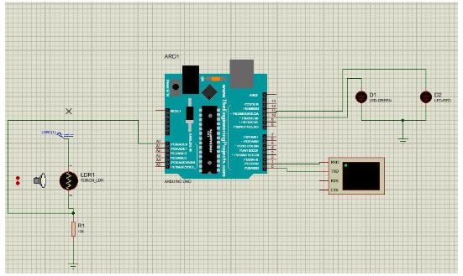
3B DIGITAL (To measure the distance from the target based on the Ultrasonic waves)
const int pingPin=7;
const int echoPin=6;
void setup(){
Serial.begin(9600);}
void loop(){
long duration, inches, cm;
pinMode(pingPin,OUTPUT);
digitalWrite(pingPin, LOW);
delayMicroseconds(2);
digitalWrite(pingPin, HIGH);
delayMicroseconds(10);
digitalWrite(pingPin, LOW);
pinMode(echoPin, INPUT);
duration =pulseIn(echoPin,HIGH);
inches=microsecondsToInches(duration);
cm=microsecondsToCentimeters(duration);
Serial.print(inches);
Serial.print("in, ");
Serial.print(cm);
Serial.print("cm");
Serial.println();
delay(100);}
long microsecondsToInches(long microseconds){
return microseconds / 74 / 2;}
long microsecondsToCentimeters(long microseconds){
return microseconds / 29 / 2;}
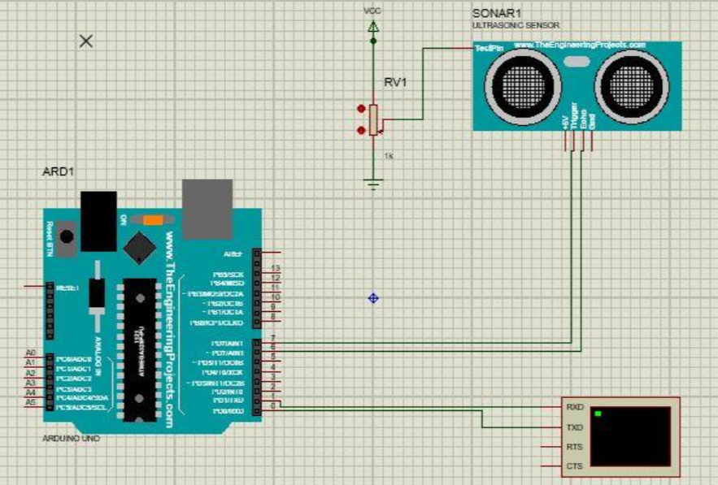
4. LED / BUZZER
const int LED=10;
void setup(){
pinMode(LED,OUTPUT);}
void loop(){
digitalWrite(LED,HIGH);
delay(1000);
digitalWrite(LED,LOW);
delay(2000);}
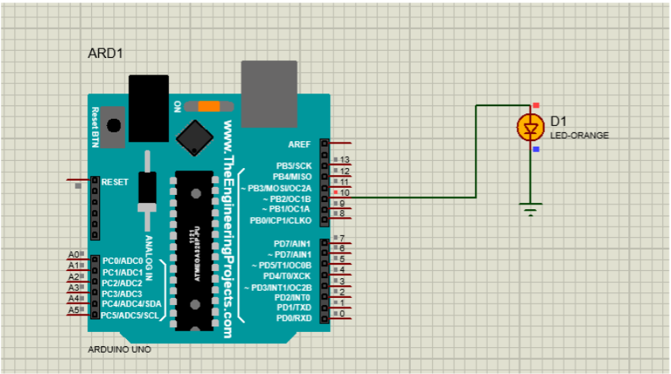

5. PIR
const int pirpin=3;
const int ledpin=13;
void setup(){
pinMode(pirpin,INPUT);
pinMode(ledpin,OUTPUT);
Serial.begin(9600);}
void loop(){
int motionState=digitalRead(pirpin);
if(motionState==HIGH){
digitalWrite(ledpin, HIGH);
Serial.println(" Motion Detected");}
else{
digitalWrite(ledpin,LOW);
Serial.println("Motion Stopped");}
delay(1000); }
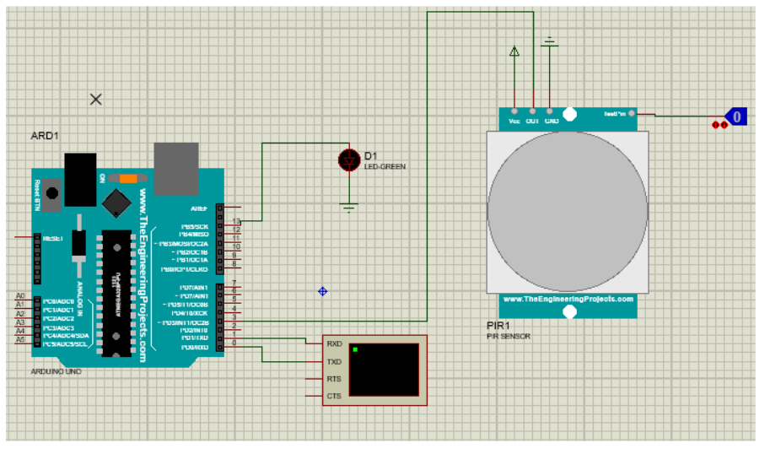
6. DHT22
#include <DHT.h>
#include <LiquidCrystal.h>
LiquidCrystal lcd(12, 11, 5, 4, 3, 2); // LCD pin connection (RS, E, D4, D5, D6, D7)
#define DHTPIN 13
#define DHTTYPE DHT22
DHT dht(DHTPIN, DHTTYPE);
void setup() {
lcd.begin(16, 2);
Serial.begin(9600);
dht.begin();
lcd.print("System Starting");
delay(2000);
lcd.clear();}
void loop() {
float temp = dht.readTemperature();
float hum = dht.readHumidity();
if (isnan(temp) || isnan(hum)) {
lcd.clear();
lcd.print("Sensor Error");
Serial.println("Failed to read from DHT22");
delay(2000);
return;
}
lcd.clear();
lcd.setCursor(0, 0);
lcd.print("Temp: ");
lcd.print(temp);
lcd.print(" C");
lcd.setCursor(0, 1);
lcd.print("Hum: ");
lcd.print(hum);
lcd.print(" %");
Serial.print("Temperature: ");
Serial.print(temp);
Serial.println(" C");
Serial.print("Humidity: ");
Serial.print(hum);
Serial.println(" %");
delay(2000);}
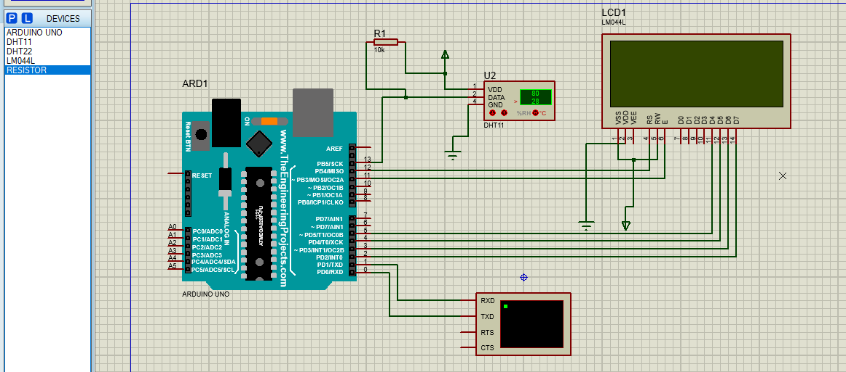

7. FLAME SENSOR
#include <LiquidCrystal.h>
LiquidCrystal lcd(13, 12, 11, 10, 9, 8);
const int SensorPin = 2;
const int LEDPin = 7;
void setup()
{
pinMode(SensorPin, INPUT);
pinMode(LEDPin, OUTPUT);
lcd.begin(20, 4);
lcd.setCursor(0,0);
lcd.print(" THE BRIGHT LIGHT ");
lcd.setCursor(0,1);
lcd.print(" FIRE DETECTION SYS");}
void loop(){
if(digitalRead(SensorPin) == HIGH){
digitalWrite(LEDPin,HIGH);
lcd.setCursor(0,3);
lcd.print(" Fire Detected ");
delay(70);
lcd.setCursor(0,3);
lcd.print(" Fire Detected. ");
delay(70);
lcd.setCursor(0,3);
lcd.print(" Fire Detected.. ");
delay(70);
lcd.setCursor(0,3);
lcd.print(" Fire Detected... ");
delay(70);}
else{
digitalWrite(LEDPin,LOW);
lcd.setCursor(0,3);
lcd.print(" No Fire ");}}
